Education Outcomes of Compulsory Schooling Law

Literature Review

What is CSL?

Compulsory schooling laws specify an entry age by which the child is required to attend school and a dropout age at which the child can choose to unconditionally stop attending school. There are two primary types of exceptions frequently written into schooling laws that allow children to stop attending school before the drop out age. The first type of exception allows children to stop attending if they have completed a specified number of schooling years.5 The second type of exception allows children to be excused from school attendance if they have secured employment and have also reached both minimum age and years of schooling requirements. States typically have either the first or second type of exception; only in a handful of cases do states provide both types of exceptions (Stephs & Yang 3).

(​​The compulsory schooling measures that primarily have been used in the prior literature are the two measures coded by Acemoglu and Angrist (2000). Their first measure is based only on the schooling attendance portion of the legal statutes. Compulsory attendance (CAst) for those born in state s in year t is computed as:)



(Stephs & Yang 4).

Why do we care?

Oreopoulos and Salvanes (2011) note in their recent survey of the literature that there is a growing literature examining the effect of schooling across a variety of domains outside of the labor market including, but not limited to, health, crime, and family formation.

The OLS estimates in column (1) are all significant and in the expected direction with more schooling leading to increased wages, higher occupational prestige, and less unemployment. The 2SLS estimates in column (2) using the baseline specification yield estimates in the same direction, all of which are statistically significant.

(no evidence of benefits to additional schooling using variation generated by compulsory schooling laws because of discount rate and low private return from additional years of schooling Carneiro, Heckman, and Vytlacil (2011).)

<https://www.nber.org/system/files/working_papers/w19369/w19369.pdf>

Why Mexico?

The Organisation for Economic Co-operation and Development (OECD) is an international organization comprising countries committed to democracy and the market economy.

Among OECD countries where the qualification exists, the share of younger adults with vocational upper secondary attainment varies widely across OECD countries. On average across OECD countries, 20% of 25-34 year-olds have vocational upper secondary education as their highest level of education. In Mexico, 1% of younger adults have this level of educational attainment, while in Finland and Slovenia, the share is almost 40%, and it reaches 48% in the Slovak Republic.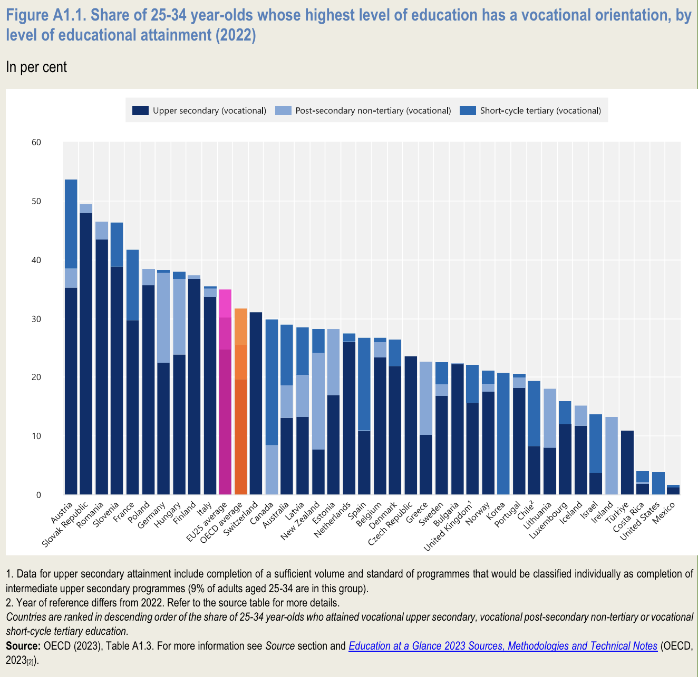

Among OECD countries, these percentages are highest in Costa Rica (46% of young men and 37% of young women) and Mexico (43% of young men and 43% of young women). Below upper secondary attainment As upper secondary or post-secondary non-tertiary education has become more important for participation in modern economies, the share of those with below upper secondary education has declined, albeit unevenly. Among younger adults (25-34 year-olds).

Mexico has the highest out-of-school rate among all OECD and partner countries, with around 29% of upper secondary-aged youth not enrolled in 2021

Between 2005 and 2021, among the 20 countries with data available for both years, some achieved large decreases in out-of-school rates at the upper secondary level. This is the case in Australia (where the rate fell by 6 percentage points), Denmark (7 percentage points), and Mexico (16 percentage points).

progress still needs to be made

https://www.oecd-ilibrary.org/docserver/e13bef63-en.pdf?expires=1716938191&id=id&accname=ocid194641&checksum=A9108F8C5480E8389723E59050C4B54E

Mexico CSL Trajectory

The first general law of education was issued in 1939, legalizing what SEP had, de facto, built since 1921. The law was later reformed in 1942, 1973, 1993, and 2019, with changes related to rhetoric, allocation of teachers and ways of teacher promotion, sharing of managing duties between SEP and the federal states’ education ministries, increase in the number of years of compulsory schooling, and expansion of the definition of the right of the people to education.

1939 / 1946/ 1993/ 2004/ 2013

**1934** Primary school comprises 6 years (all 6 years have been compulsory since 1934).

**1939** was when the proposal for free, universal, and a-religious **primary education** was approved. This article mandated that education be provided by the federal government and of a socialist character (primary ages 6-10)

**1942** Focused on rebuilding post-war education, modernizing the curriculum, improving teacher training, and expanding access.

**1946** saw an amendment to the 3rd article that removed the socialist quality of federal, public Mexican education - changing the character of education, changing future reforms (less rural focused going forward, then more focus on the urban Centers, approved private education like Tec)

**1973** Emphasized inclusivity, comprehensive education, lifelong learning, decentralization, and technological integration.

**1993 *middle school (lower and upper secondary education were made compulsory)*** added to the period of free, obligatory, government-provided schooling

**2004 *preeschool***added to the period of free, obligatory, government provided schooling

**2013 *high-school***added to a period of free, obligatory, government provided schooling

The data relating to secondary education reveal sustained growth in the different strata over the last 15 years (2003-2018), especially in those whose attention is oriented towards the population in rural areas. From 2001-2002 to 2007-2008 there was an increase of 3.1% in general secondary schools in rural areas, with an increase in enrollment of 4.3%.

Due to the mandatory decree, this type of education had a new boost that translated into an increase in the educational options offered by the entities. State schools registered the largest increase in enrollment: 7.1, 5.4 and 4.2%, in each of the last three six-year terms.

**2019** promote educational equity, update the curriculum for 21st-century skills, and integrate technology. It emphasized teacher development, student well-being, and global competence. Additionally, it improved assessment methods to better support learning outcomes.

https://www.inee.edu.mx/medios/informe2018/04_informe/capitulo_020101.html#:~:text=Desde%201993%20la%20educaci%C3%B3n%20secundaria,educaci%C3%B3n%20obligatoria%2C%20en%20ese%20orden.

a new general law of education (1993), SEP transferred to the federal states’ governments the administration of primary, secondary, and normal schools; however, SEP retained key functions such as the financing of schools, payment of teachers (via money transfers to the governments of the federal states), curricular design, production of primary school textbooks, and the evaluation of teachers throughout the country (Arnaut 2010).

Primary school comprises 6 years (all 6 years have been compulsory since 1934).

**Lower secondary schoo**l (compulsory since 1993) comprises 3 years for adolescents aged **12 to 15** years. There are five modalities of lower secondary education: general, technical, *telesecundaria*, community, and for workers.*Telesecundaria* (created 1968) is a modality whereby teaching is conducted by one teacher with the support of television broadcasts that cover different disciplines; it covers 20% of the secondary education demand. Technical secondary school attendance can lead to employment in the labor market.

<https://link.springer.com/referenceworkentry/10.1007/978-3-030-41651-5_11#Sec1>

CSL chosen?

Look into the policy

Shed light of the impacts of the 1993 compulsory schooling raise compulsory school-leaving age from 12 to 15 years (Erendira)

"Article 3.- Every individual has the right to receive education. The State - Federation, States and Municipalities will provide preschool, primary and secondary education. Primary and secondary education are mandatory.

​​represented a broader and more comprehensive approach to compulsory education in Mexico compared to the 1946 law.

<https://www.diputados.gob.mx/bibliot/publica/inveyana/polint/cua2/evolucion.htm>

<https://ideas.repec.org/p/boc/lsug22/07.html#>

Erendira Leon Bravo, 2022. "[Estimating Compulsory Schooling Impacts on Labour Market Outcomes in Mexico using Fuzzy Regression Discontinuity Design (RDD) with parametric and non-parametric analyses](https://ideas.repec.org/p/boc/lsug22/07.html)," [London Stata Conference 2022](https://ideas.repec.org/s/boc/lsug22.html) 07, Stata Users Group.

<https://link.springer.com/referenceworkentry/10.1007/978-3-319-93443-3_11-1?fromPaywallRec=false>

<https://www.gob.mx/cms/uploads/attachment/file/414157/OECD_Mexico_Schools_Report_FINAL.pdf>

Regression: <https://ideas.repec.org/p/boc/lsug22/07.html>

Education Policy Outlook

<https://www.oecd-ilibrary.org/education/education-policy-outlook-2015_9789264225442-en>

Education Policy Outlook Snapshot: Mexico

<https://www.oecd.org/education/highlightsMexico.htm>

<https://wenr.wes.org/2019/05/education-in-mexico-2>

**1993 *middle school (lower and upper secondary education were made compulsory)*** added to the period of free, obligatory, government provided schooling

Significant reformation after 1939 primary education been approved.

Also with respect to Mexico years of surveys available on IPUMS:

1960

1970

1990

1995

2000

2005

2010

2015

2020

I chose the 1993 compulsory schooling law because it has complete data in previous LB and UB for age requirements compared to the 1946 law. It is less recent compared to the 2013 law which means we have more data samples. 2013 law, 2020 survey, not so many who were grown up and were affected by the policy in 2020, only possible for those who were older than 11 and younger than 18 in 2013.

Therefore, for the 1993 law, I will choose the 2010 survey which was the latest survey before the next law implementation in 2013.

Focus/ Research Question

Do discontinuities occur in the secondary education attainment of urban and rural populations after the implementation of the 1993 reformation?

Research Design

Collecting survey data from IPUMS on the Mexico census centered around the variables of birth year, educational attainment, gender, urban-rural status, and migration.

Assumed independence within and between the census samples’ populations.

Cleaning data in Stata, following standard academic procedures for reproducibility.

Performed linear regression on mean Secondary School education attainment rate by year search for a discontinuity.

Graph/map additional trends in the educational data across gender, urban & rural, and migration status.

Graphs/Observations

Discontinuity on Mean Secondary School Attainment by year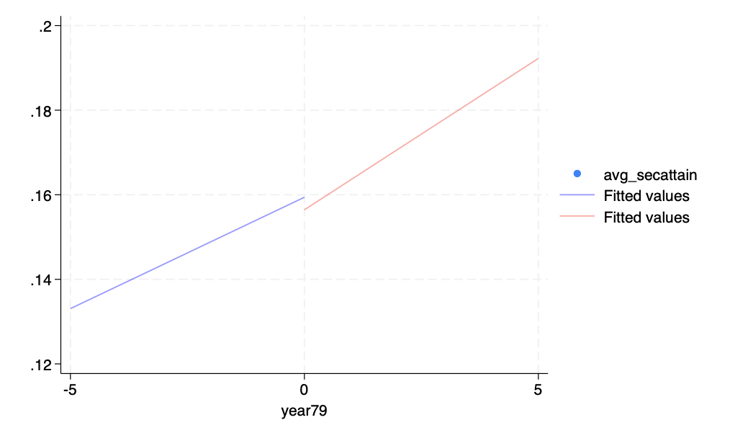

Literacy discontinuity

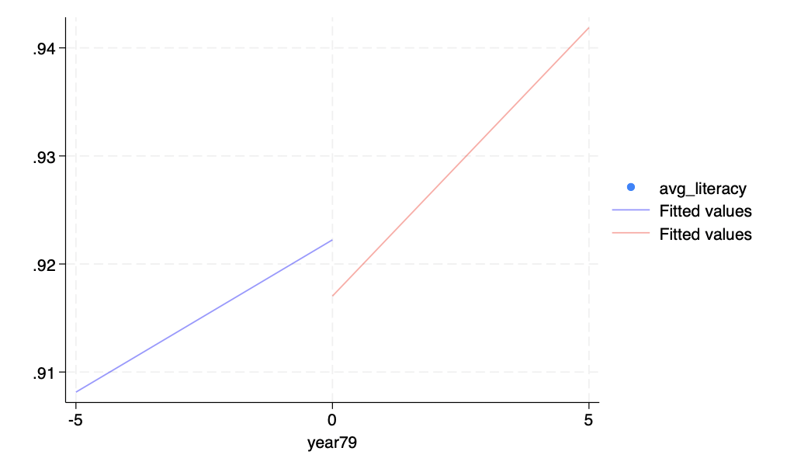

Discontinuity on Mean years of schooling

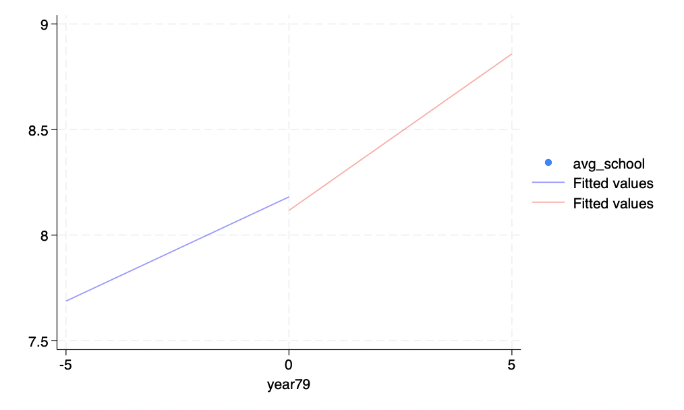

change the cuttoff from exactly as year 0 to a later year at 5 to show discontiuity on Mean Secondary School Attainment by year

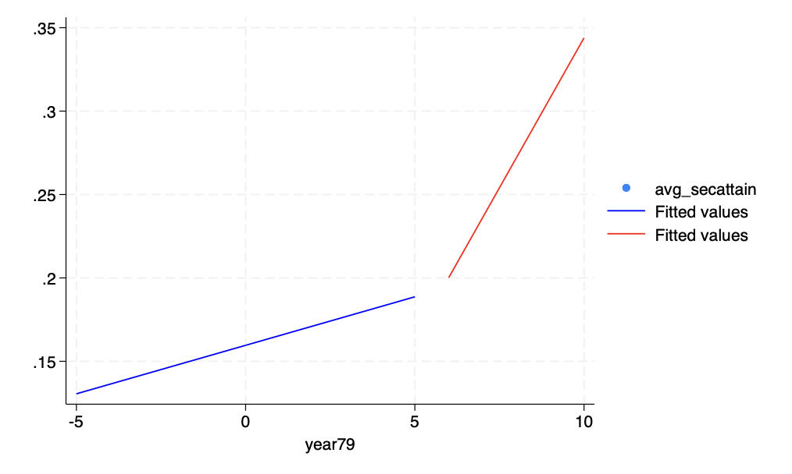

change the cuttoff from exactly as year 0 to a later year at 5 to show discontiuity on Mean literacy by year

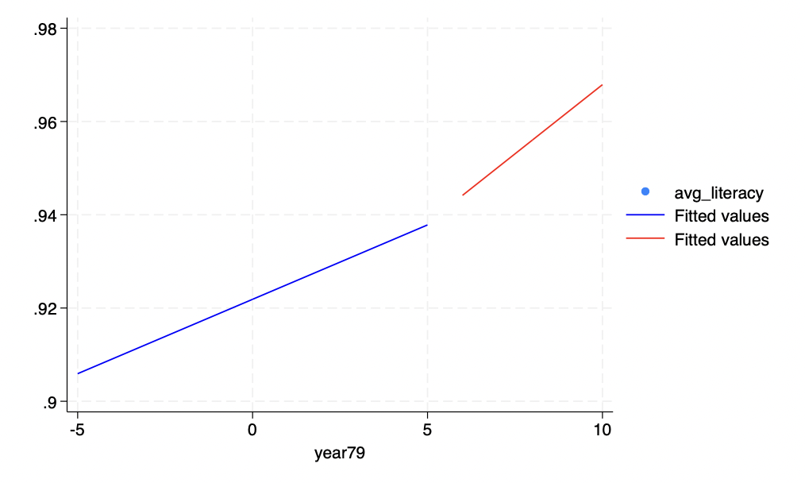

change the cuttoff from exactly as year 0 to a later year at 5 to show discontiuity on Mean years of schooling by year

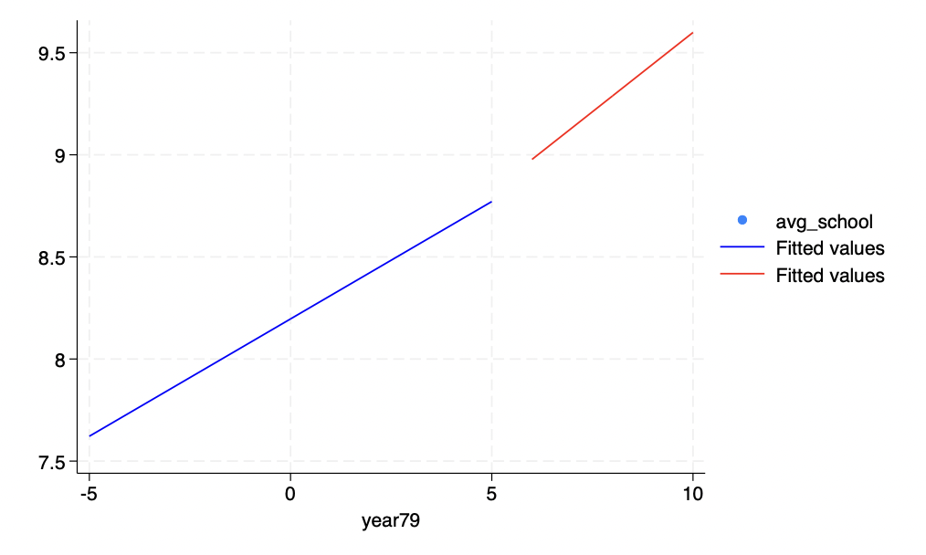

Compare effects on different cohorts

Migration data

<https://www.citypopulation.de/en/mexico/cities/>

